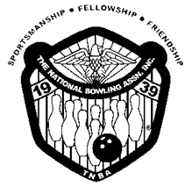
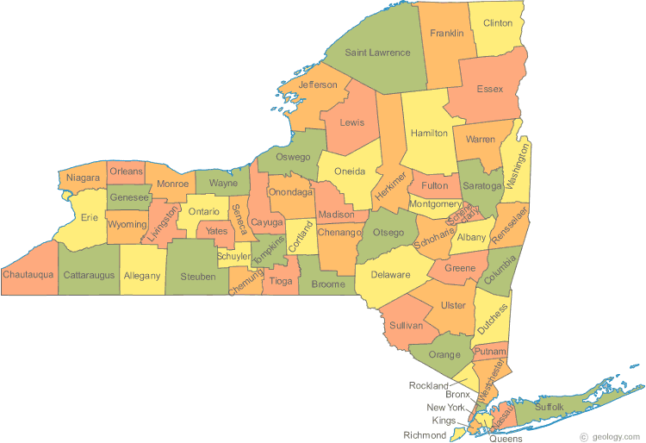
11th Annual

Samuel Surgick

Doubles Tournament

Hosted by Albany Senate

 | DOUBLES | SINGLES  (optional) | SCRATCH  (optional)
First Place Prize Fund: | $3,000 | $500 | $500
Doubles prize based on 300 entries
Handicap prize fund is based on 200 entries / Scratch prize fund is based on 200 entries
Lane Sponsor: Cost is $100.00. Banner will be placed above the lane you sponsor
Payment Methods
Cash

Venmo - @albanytnba

Zelle - albanytnba@gmail.com

Certified checks or money orders payable to “Albany TNBA” (no personal checks)

Sponsored by: Hammer
Turbo
Many Styles of Bowling & CTD
Squad Times:
Saturday - April 29, May 6
Sunday - April 30, May 7

10:00AM, 12:00PM, 2:30PM, 5:00PM
Special
1st Weekend Only
Bowl 3 squads get the 4th squad free.
The free entry can be used either weekend, but 3 squads must be bowled the 1st weekend.
Prepay Special - $54.00 per team until April 15, 2022
As of April 16, 2022 - $64.00 per team

Optional Handicap & Scratch Singles - $10.00 per person

Hotel Info.
Fairfield Inn by Marriott Albany - East Greenbush
124 Troy Road
East Greenbush, NY

(518) 477-7984
www.marriott.com/ALBEG
$115.00 + tax per night

BOWLERS MUST BE CERTIFIED BY TNBA AND USBC
Go to www.tnbainc.org for more information about us

Membership cards may be purchased at the tournament site
Brackets

Scratch/Handicap
Jackpots

Mystery Game

Raffles
50/50
Bowling Balls

Tournament Location:
East Greenbush Bowl
570 Columbia Turnpike
East Greenbush, NY
(518) 477-9306

Mail entries to: PO Box 1371, Albany, NY 12201

For More Information Contact
FAILURE TO READ IS NO EXCUSE
Tournament Rules:
- This tournament shall be USBC and TNBA certified, is open to all sanctioned members of the USBC and TNBA and shall operate under the Rules of the USBC and TNBA.
- Non-members may enter by paying a membership fee of $30.00 for USBC and/or TNBA membership of $30.00.
- The tournament shall commence on Saturday, April 29, 2023 and run for two (2) consecutive weekends ending on Sunday,
May 7, 2023.
- Teams will consist of 2 men, 2 women or mixed.
- Entering Averages:
  - Higher of your book or composite USBC league average for 2019/2020 or 2020/2021. Book average must be 36 games or more.
  - If no 2019-2020 or 2020-2021 average, you may go back to 2018–2019 season with minimum of 50 games for the season. Bowler can use current 2019/2020 average if bowler has more than 36 games and none of the above apply.
  - Bowlers must bowl scratch with an average of 230 if above rules don’t apply. Summer averages included if a minimum of 21 games.
  - Bowler’s highest league average for 21 games or more from a USBC Certified Sport League will be
automatically re-rated.
  - TEN PIN RULE: If your average for 2021/2022 (minimum of 21 games) is higher by 10 pins or more than the 2019/2020 or 2020/2021 average, the average for 2021/2022 must be used (USBC Rule 319a-2).
- It shall be each bowler’s responsibility to verify the accuracy of his/her average, whether submitted by the bowler, his/her partner or others. Failure to use the correct average or make corrections prior to the completion of the series will result in disqualification. (USBC Rue 319a-3). There are no refunded entry fees for those disqualified.
- The Tournament Director reserves the right to re-rate any bowler prior to bowling. If the bowler does not accept the
re-rate average, the entry fee shall be returned (USBC Rule 319c).
- Team handicap will be based on 80% of the difference between the team average and 440. Singles handicap will be
based on 80% of the difference between the bowler’s average and 220. All averages over 220 must bowl scratch.
- All teams will bowl three (3) games on the same pair of lanes with highest total pins plus handicap deciding the
tournament winner.
- Re-entries are permitted in the Doubles and Singles events. Bowlers can cash multiple times in the Doubles event, but only
once with the same partner and can cash only once in the Singles event.
- Prize fund is 100% returned.
- All decisions of the Tournament Director are final regarding any and all disputes, unless an appeal is made in writing. Appeals must be made within 72 hours to the Tournament Director to be considered.

Squad Date and Time: ___________________________________________________

1. | Name (Print) No Nicknames: | M/F | End Avg. (20-21) | End. Avg. (21-22)
 | Telephone Number: | USBC # |  | TNBA #
 | Email Address: | Singles HDCP Entry # ______  YES NO |  | Singles Scratch Entry#_____  YES NO
 | Home Address:
2. | Name (Print) No Nicknames: | M/F | End Avg. (20-21) | End. Avg. (21-22)
 | Telephone Number: | USBC # |  | TNBA #
 | Email Address: | Singles HDCP Entry # ______  YES NO |  | Singles Scratch Entry# _____  YES NO
 | Home Address:

For Official Use Only:

Amount Received: ___________________________ Date Amount Received: _______________________

Payment Type: Cash Check Other Venmo Zelle

